**ReactJS-HOL 9**

**Create a React Application named “cricketapp”:**

**Code:**

**ListofPlayers.js**

import React from 'react';

const ListofPlayers = () => {

  const players = [

    { name: 'Virat Kohli', score: 85 },

    { name: 'Rohit Sharma', score: 95 },

    { name: 'KL Rahul', score: 65 },

    { name: 'Shubman Gill', score: 45 },

    { name: 'Hardik Pandya', score: 70 },

    { name: 'Jasprit Bumrah', score: 90 },

    { name: 'Ravindra Jadeja', score: 60 },

    { name: 'Rishabh Pant', score: 88 },

    { name: 'Mohammed Shami', score: 55 },

    { name: 'Axar Patel', score: 73 },

    { name: 'Shreyas Iyer', score: 68 },

  ];

  const below70 = players.filter(player => player.score < 70);

  return (

    <div>

      <h2>All Players and Scores:</h2>

      <ul>

        {players.map((player, index) => (

          <li key={index}>{player.name} - {player.score}</li>

        ))}

      </ul>

      <h3>Players with Score Below 70:</h3>

      <ul>

        {below70.map((player, index) => (

          <li key={index}>{player.name} - {player.score}</li>

        ))}

      </ul>

    </div>

  );

};

export default ListofPlayers;

**IndianPlayers.js**

import React from 'react';

const IndianPlayers = () => {

  const oddPlayers = ['Virat', 'KL Rahul', 'Hardik', 'Bumrah', 'Pant'];

  const evenPlayers = ['Rohit', 'Gill', 'Jadeja', 'Shami', 'Axar', 'Iyer'];

  const [odd1, odd2, ...remainingOdd] = oddPlayers;

  const [even1, even2, ...remainingEven] = evenPlayers;

  const T20players = ['Rohit', 'Virat', 'Bumrah'];

  const RanjiTrophy = ['Pujara', 'Saha', 'Karun Nair'];

  const mergedPlayers = [...T20players, ...RanjiTrophy];

  return (

    <div>

      <h2>Odd Team Players:</h2>

      <ul>

        <li>{odd1}</li>

        <li>{odd2}</li>

        {remainingOdd.map((player, idx) => <li key={idx}>{player}</li>)}

      </ul>

      <h2>Even Team Players:</h2>

      <ul>

        <li>{even1}</li>

        <li>{even2}</li>

        {remainingEven.map((player, idx) => <li key={idx}>{player}</li>)}

      </ul>

      <h3>Merged List of T20 and Ranji Trophy Players:</h3>

      <ul>

        {mergedPlayers.map((player, index) => (

          <li key={index}>{player}</li>

        ))}

      </ul>

    </div>

  );

};

export default IndianPlayers;

**App.js**

import React from 'react';

import ListofPlayers from './components/ListofPlayers';

import IndianPlayers from './components/IndianPlayers';

function App() {

const flag = true; // Change to false to test IndianPlayers

return (

<div className="App">

<h1>🏏 Welcome to Cricket App</h1>

{flag ? <ListofPlayers /> : <IndianPlayers />}

</div>

);

}

export default App;

**index.js**

import React from 'react';

import ReactDOM from 'react-dom/client';

import App from './App';

const root = ReactDOM.createRoot(document.getElementById('root'));

root.render(<App />);

**Output:**

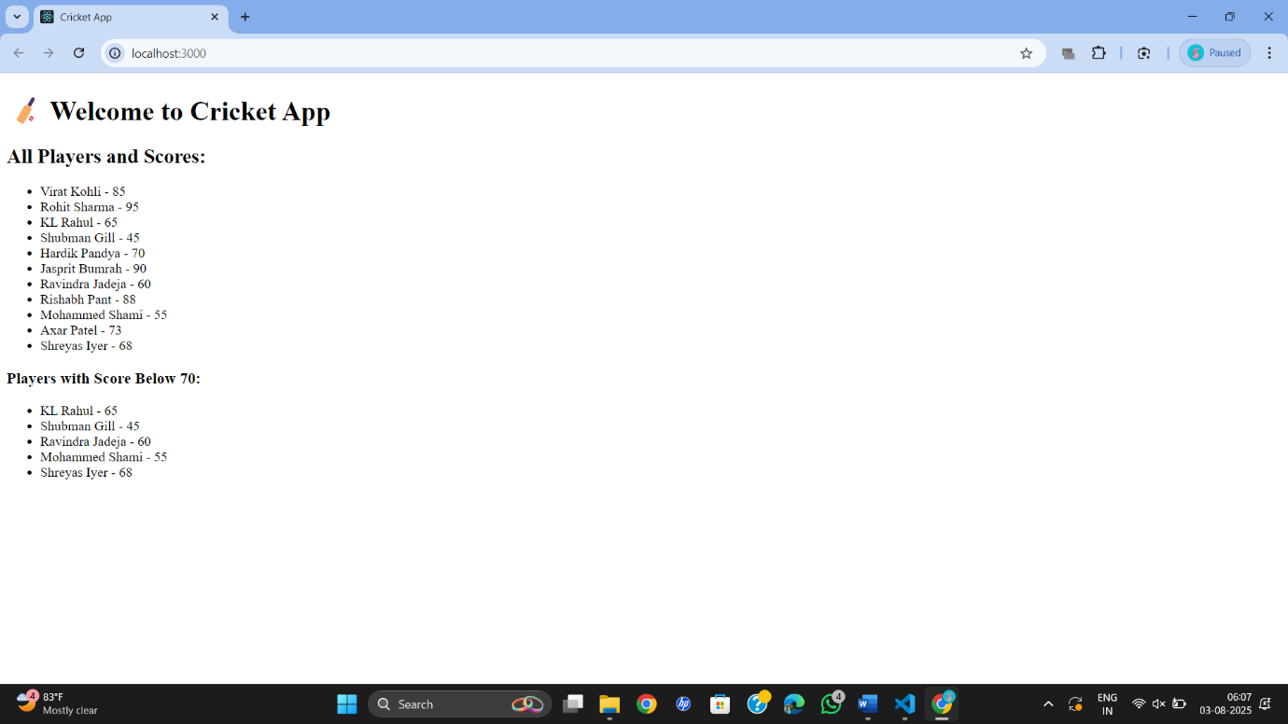

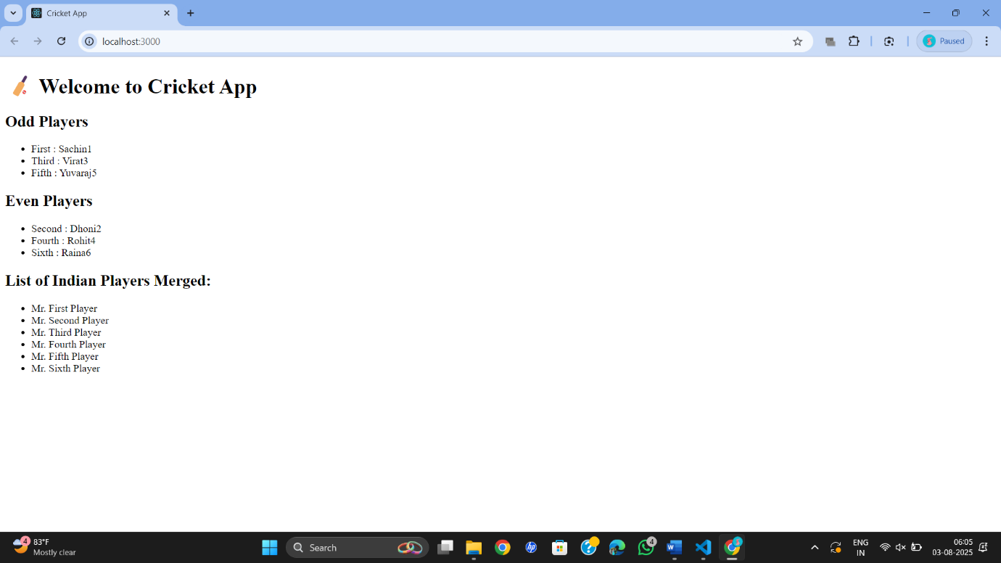

**ReactJS-HOL 10**

**Create a React Application named “officespacerentalapp” which uses React JSX to create elements, attributes and renders DOM to display the page.**

**Code:**

**OfficeSpaceList.js**

import React from 'react';

const OfficeSpaceList = () => {

  const heading = "Office Space , at Affordable Range";

  const offices = [

    {

      name: "DBS",

      rent: 50000,

      address: "Chennai",

     image: " https://encrypted-tbn0.gstatic.com/images?q=tbn:ANd9GcScNlBknk88DqcdBWIvRChtS8USNZ8v0HQZYg&usqp=CAU"

    },

    {

      name: "WeWork",

      rent: 75000,

      address: "Bangalore",

      image: " https://encrypted-tbn0.gstatic.com/images?q=tbn:ANd9GcScNlBknk88DqcdBWIvRChtS8USNZ8v0HQZYg&usqp=CAU"

    },

    {

      name: "Regus",

      rent: 55000,

      address: "Hyderabad",

      image:"https://images.unsplash.com/photo-1592833157680-85f4a7e331ff"

    }

  ];

  return (

    <div style={{ textAlign: 'center', padding: '20px' }}>

      <h1>{heading}</h1>

      {offices.map((office, index) => (

        <div key={index} style={{ border: '1px solid #ddd', padding: '15px', margin: '15px' }}>

          <img src={office.image} alt={office.name} width="300" height="200" />

          <h2>Name: {office.name}</h2>

          <h3 style={{ color: office.rent < 60000 ? 'red' : 'green' }}>

            Rent: Rs. {office.rent}

          </h3>

          <h4>Address: {office.address}</h4>

        </div>

      ))}

    </div>

  );

};

export default OfficeSpaceList;

**index.js**

import React from 'react';

import ReactDOM from 'react-dom/client';

import App from './App';

const root = ReactDOM.createRoot(document.getElementById('root'));

root.render(<App />);

**App.js**

import React from 'react';

import OfficeSpaceList from './components/OfficeSpaceList';

function App() {

  return (

    <div className="App">

      <OfficeSpaceList />

    </div>

  );

}

export default App;

**Output:**

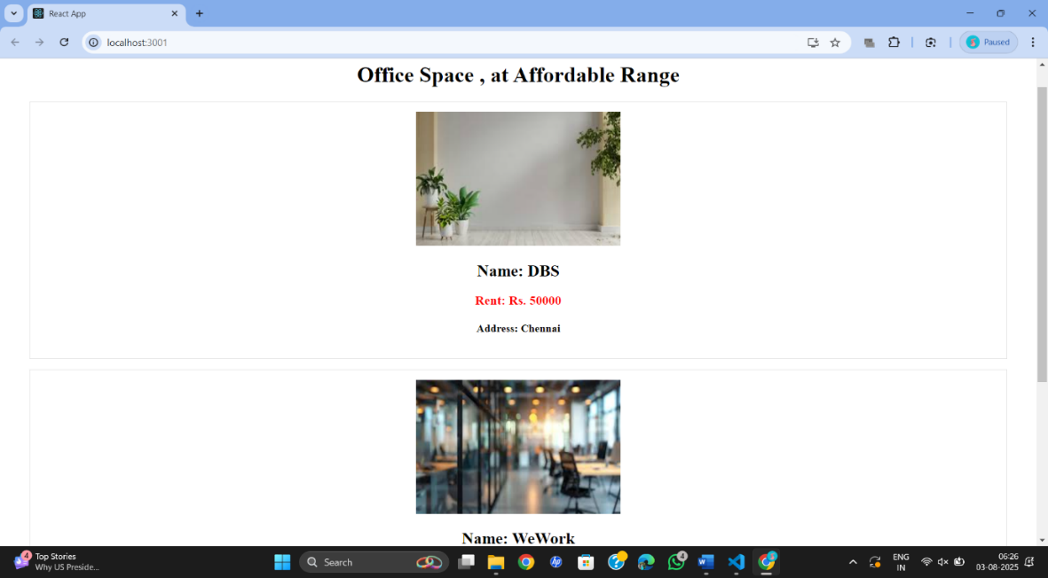

**ReactJS-HOL 11**

**Create a React Application “eventexamplesapp” to handle various events of the form elements in HTML.**

**Code:**

**App.js**

import React, { useState } from 'react';

import './App.css';

import CurrencyConvertor from './CurrencyConvertor';

function App() {

  const [count, setCount] = useState(0);

  // Multiple functions on Increment

  const handleIncrement = () => {

    incrementValue();

    sayHello();

  };

  const incrementValue = () => {

    setCount(count + 1);

  };

  const sayHello = () => {

    alert('Hello Member1');

  };

  const handleDecrement = () => {

    setCount(count - 1);

  };

  const sayWelcome = (msg) => {

    alert(msg);

  };

  const onPress = (e) => {

    alert('I was clicked');

  };

  return (

    <div style={{ padding: '20px' }}>

      <h2>{count}</h2>

      <button onClick={handleIncrement}>Increment</button> &nbsp;

      <button onClick={handleDecrement}>Decrement</button> &nbsp;

      <button onClick={() => sayWelcome('welcome')}>Say welcome</button> &nbsp;

      <button onClick={onPress}>Click on me</button>

      <hr />

      <CurrencyConvertor />

    </div>

  );

}

export default App;

**CurrencyConvertor.js**

import React, { useState } from 'react';

function CurrencyConvertor() {

  const [amount, setAmount] = useState('');

  const [currency, setCurrency] = useState('');

  const handleSubmit = (e) => {

    e.preventDefault();

    if (currency.toLowerCase() === 'euro') {

      // Example conversion rate 1 Euro = 80 INR

      const converted = amount * 80;

      alert(`Converting to Euro Amount is ${converted}`);

    } else {

      alert('Please enter currency as Euro');

    }

  };

  return (

    <div style={{ marginTop: '20px' }}>

      <h2 style={{ color: 'green' }}>Currency Convertor!!!</h2>

      <form onSubmit={handleSubmit}>

        <div>

          <label>Amount: </label>

          <input

            type="number"

            value={amount}

            onChange={(e) => setAmount(e.target.value)}

          />

        </div>

        <div>

          <label>Currency: </label>

          <input

            type="text"

            value={currency}

            onChange={(e) => setCurrency(e.target.value)}

          />

        </div>

        <button type="submit">Submit</button>

      </form>

    </div>

  );

}

export default CurrencyConvertor;

**App.css**

body {

  font-family: Arial, sans-serif;

}

button {

  margin: 5px;

  padding: 5px 10px;

}

input {

  margin: 5px;

  padding: 5px;

}

**index.js**

import React from 'react';

import ReactDOM from 'react-dom/client';

import './index.css';

import App from './App';

const root = ReactDOM.createRoot(document.getElementById('root'));

root.render(

  <React.StrictMode>

    <App />

  </React.StrictMode>

);

**Output:**

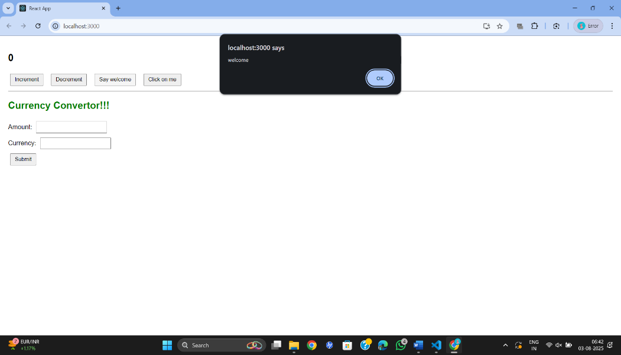

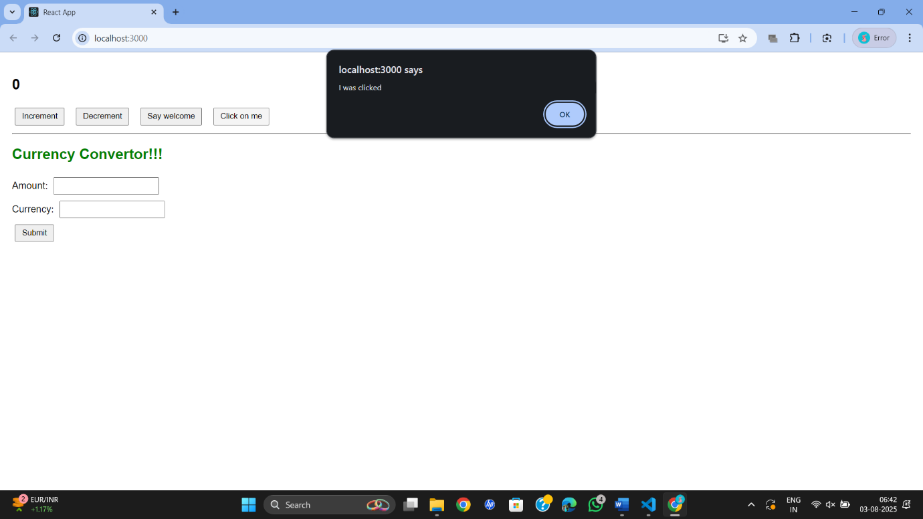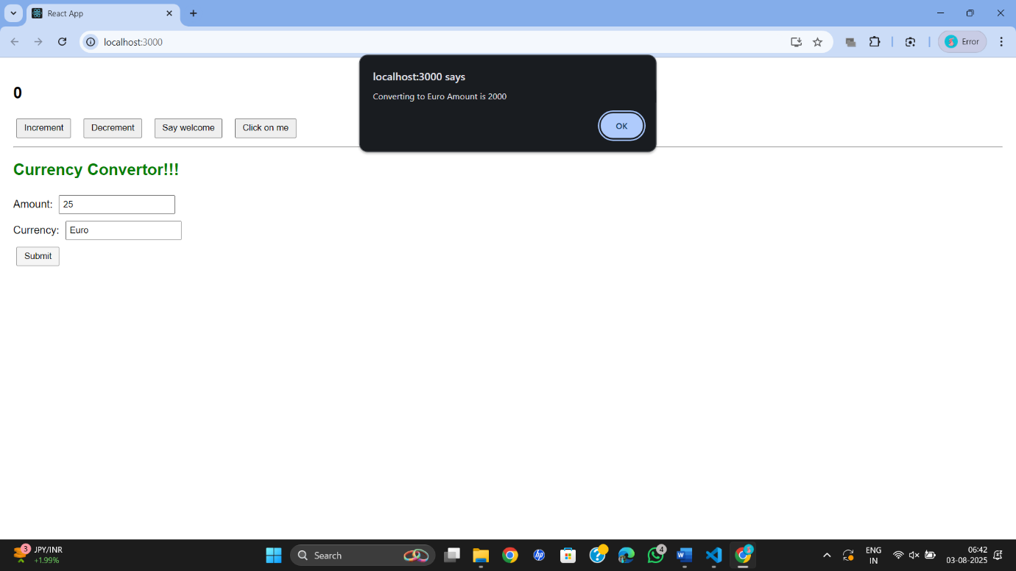

**ReactJS-HOL 12**

**Create a React Application named “ticketbookingapp” where the guest user can browse the page where the flight details are displayed whereas the logged in user only can book tickets.**

**Code:**

**App.js**

import React, { useState } from 'react';

function LoginButton(props) {

return (

<button onClick={props.onClick}>

Login

</button>

);

}

function LogoutButton(props) {

return (

<button onClick={props.onClick}>

Logout

</button>

);

}

function Greeting(props) {

if (props.isLoggedIn) {

return <h2>Welcome back</h2>;

}

return <h2>Please sign up.</h2>;

}

function App() {

const [isLoggedIn, setIsLoggedIn] = useState(false);

const handleLoginClick = () => {

setIsLoggedIn(true);

};

const handleLogoutClick = () => {

setIsLoggedIn(false);

};

let button;

if (isLoggedIn) {

button = <LogoutButton onClick={handleLogoutClick} />;

} else {

button = <LoginButton onClick={handleLoginClick} />;

}

return (

<div style={{ textAlign: 'center', marginTop: '50px' }}>

<Greeting isLoggedIn={isLoggedIn} />

{button}

</div>

);

}

export default App;

**index.js**

import React from 'react';

import ReactDOM from 'react-dom/client';

import App from './App';

const root = ReactDOM.createRoot(document.getElementById('root'));

root.render(

    <React.StrictMode>

        <App />

    </React.StrictMode>

);

**Output:**

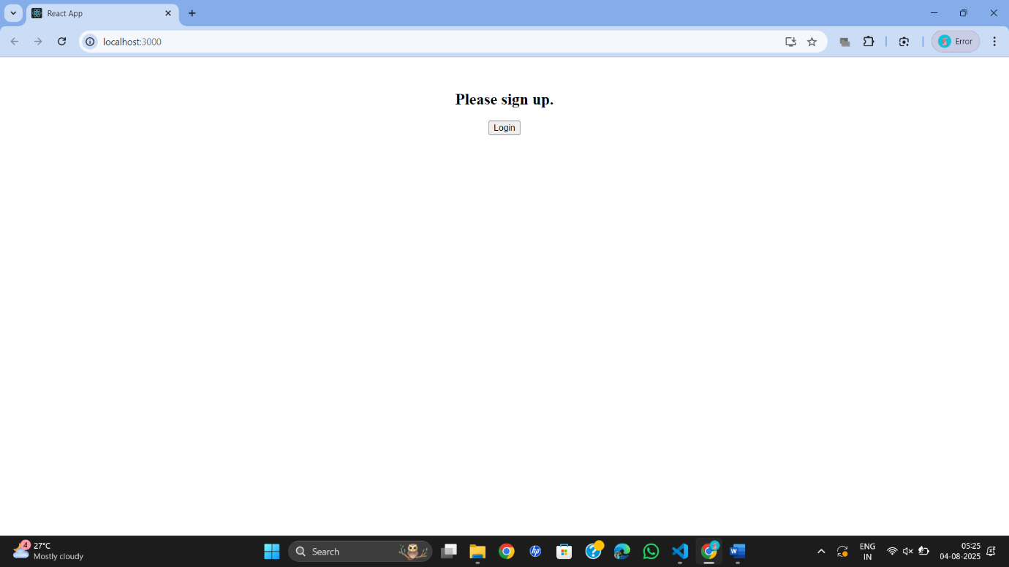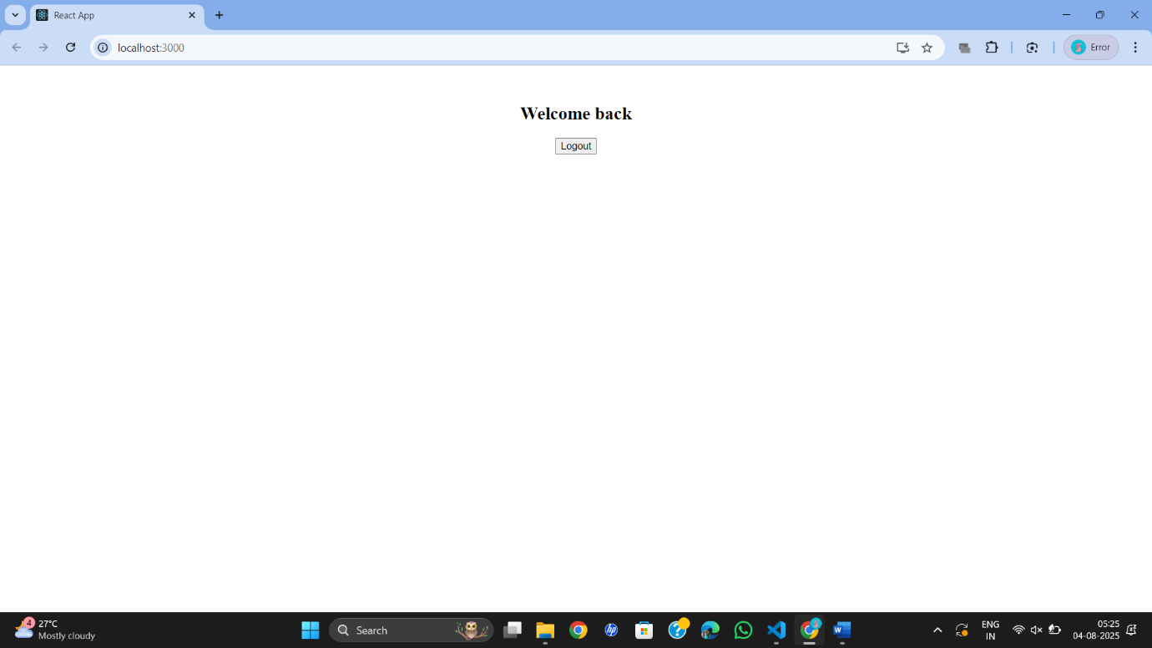

**ReactJS-HOL 13**

**Create a React App named “bloggerapp” in with 3 components.**

1. **Book Details**
2. **Blog Details**
3. **Course Details**

**Code:**

**BookDetails.js**

import React from 'react';

const BookDetails = (props) => {

return (

<div className="st2">

<h1>Book Details</h1>

<ul>

{props.books.length > 0 ? (

props.books.map(book => (

<div key={book.id}>

<h3>{book.bname}</h3>

<h4>{book.price}</h4>

</div>

))

) : (

<p>No Books Available</p>

)}

</ul>

</div>

);

};

export default BookDetails;

**BlogDetails.js**

import React from 'react';

const BlogDetails = ({ blogs }) => {

return (

<div className="v1">

<h1>Blog Details</h1>

{blogs.length && blogs.map((blog, index) => (

<div key={index}>

<h3>{blog.title}</h3>

<b>{blog.author}</b>

<p>{blog.content}</p>

</div>

))}

</div>

);

};

export default BlogDetails;

**CourseDetails.js**

import React from 'react';

const CourseDetails = ({ courses }) => {

if (courses.length === 0) {

return (

<div className="mystyle1">

<h1>Course Details</h1>

<p>No Courses Available</p>

</div>

);

}

return (

<div className="mystyle1">

<h1>Course Details</h1>

{courses.map((course, index) => (

<div key={index}>

<h3>{course.cname}</h3>

<h4>{course.date}</h4>

</div>

))}

</div>

);

};

export default CourseDetails;

**App.js**

import React from 'react';

import BookDetails from './components/BookDetails';

import BlogDetails from './components/BlogDetails';

import CourseDetails from './components/CourseDetails';

import './App.css';

export const books = [

{ id: 101, bname: 'Master React', price: 670 },

{ id: 102, bname: 'Deep Dive into Angular 11', price: 800 },

{ id: 103, bname: 'Mongo Essentials', price: 450 },

];

const blogs = [

{ title: 'React Learning', author: 'Stephen Biz', content: 'Welcome to learning React!' },

{ title: 'Installation', author: 'Schwezdenier', content: 'You can install React from npm.' },

];

const courses = [

{ cname: 'Angular', date: '4/5/2021' },

{ cname: 'React', date: '6/3/2021' },

];

function App() {

const showCourses = true; // Conditional flag

const showBooks = true;

const showBlogs = true;

return (

<div style={{ display: 'flex', justifyContent: 'space-around', marginTop: '20px' }}>

{showBooks && <BookDetails books={books} />}

{showBlogs && <BlogDetails blogs={blogs} />}

{showCourses ? <CourseDetails courses={courses} /> : <p>No Courses to Display</p>}

</div>

);

}

export default App;

**index.js**

import React from 'react';

import ReactDOM from 'react-dom/client';

import App from './App';

const root = ReactDOM.createRoot(document.getElementById('root'));

root.render(<App />);

**App.css**

.st2, .v1, .mystyle1 {

border-left: 4px solid green;

padding-left: 15px;

}

**Output:**

